**Game Design**

**Characters**

Player - Aaron the Alien

Enemies - Human Aircraft

**Target Audience:** All ages/Java HTML gamers

**Game Mechanics**

*The game mechanics describe the game play in detailed terms, starting with the vision of the core game play, followed by the game flow, which traces the player activity in a typical game. The rest is all the infinite details.*

Game screen remains static but scrolling stars gives the impression of an upwards flying ship with the player starting in the centre of the screen. Player can move around the screen on both x and y axis to the full length of  the screen height and width and is able to rotate.

3 different enemies will appear randomly from the edges of the screen. There will be a maximum number of enemies allowed to spawn on the screen at any given time. The player will be able to shoot enemies provided the shoot cooldown timer has reset or if the bullet intercepts the enemy in which the enemy will disappear. For each enemy killed the player score will go up by 100 points.

**Core Game Play**

*In a few paragraphs describe the essence of the game. These few words are the seeds from which the design should grow. Planted in the fertile soil of a known market, they should establish roots that anchor the vision firmly in place and help ensure a successful game. This is similar to the description section in the game concept, except that it’s non-narrative and usually expressed clearest in bullet points, though this could vary depending on the type of game.*

* there are enemies
* shoot the enemies to score points
* player is given 1 life. If you collide with an enemy the game is over.

**Game Description**

Aliens from their home planet of Bergzodia are cruising to Earth (Year 2146 AKA 2F) from space to eliminate the remaining human race in orbit around Earth.

**Controls**

W / Up Arrow Key = Up

A / Left Arrow Key = Left

S / Down Arrow Key = Down

D / Right Arrow Key = Right

Spacebar = Shoot

Enter = Game Play

**GAME FLOWCHART**

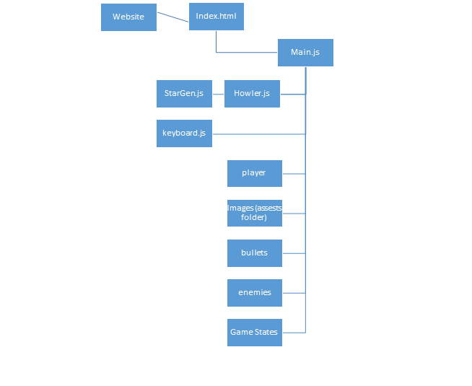

**TASKS AND RESPONSIBILITIES:**

**Graphics -** Grant & Ryan

**Enemies -** Aidyn

**Player -** Brad

**Music -** Grant

**StarGen -** Brad

**Respawning -** Ryan

**Lives -** Ryan

**Score -** Grant & Brad

**Website -** Grant & Ryan

**Debugging -** Group

**Main -** Group

**Game run -** Aidyn

**Design Document -** Group

**Items changes**

**Original background** - changed to flying effect with stars moving in background

**Pause state** - Removed

**HUD -**  Design changed

**Boss** - Removed

**JS Files** - Some .js files collaborated

**Trello Tasks**

